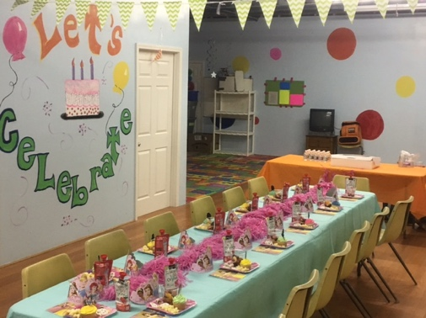 

North Metro Gymnastics Center

109 Smokehill Lane  
Woodstock, Georgia 30188

Website: northmetrogymnastics.com

Phone: 770-384-8058

#### Come join the PARTY!

**It’s Time To**





## Day of Your Party



### **We invite you to come spend your birthday with us!**

🙞 🙜

*WHERE?*

AT

**NORTH METRO GYMNASTICS CENTER**

For every birthday party, the North Metro Gymnastics Center birthday party staff will provide an exciting and unique experience to all participants.

Activities include exhilarating games, gymnastics obstacle courses, gymnastics skills, and more!

We are all about creating a fun experience and creating memories that will last a lifetime!

**Call us today!**

**770-384-8058**

🙞 🙜

NMGC staff will take care of setting up the gym and the birthday party room.

Please arrive 15-20 minutes prior to the start of the party to allow time for set-up of cake and extra decorations.

Be sure to bring a birthday cake and/or ice cream, drinks, and snacks.

Please also bring any needed utensils (such as: paper plates or bowls, napkins, cake knife, etc.)

*Note: tips are optional & are greatly appreciated



**Important Things to Know**

All birthday parties are required to pay a non-refundable $50.00 deposit to reserve a day and time.

Liability waivers must be signed by a legal guardian for each child not currently enrolled at North Metro before the party starts. Waivers are available at the gym the day of your party.

Each birthday party lasts an hour and a half; we recommend coming in at least fifteen minutes early to setup any food or extra decorations.

All participants are required to be at least 3 years of age or older. Children under the age of 3 years old are not allowed on any equipment.

We request that parents observe the party from the observation balcony, along with any siblings or small children not participating in the party. Pictures are more than welcome to be taken during the party.

**Birthday Party Package**

* Birthday party prices vary depending on the number of participants:

|  |  |  |
| --- | --- | --- |
| Number of Participants | NMGC Member | Non-Member |
| Base price (Up to 15 Kids) | **$250** | **$280** |
| 16 -35 Kids | **Base price + $10 per child** | |

* Each party is a total of 1 ½ hours of fun!

***1 Hour* = Gym Time**

***30 Minutes* = Birthday Party Room**

* NMGC staff will take care of set up prior to the party and will clean up once the party is finished.

* + The Birthday Party Room will be set up with tables, chairs, and tablecloths.
  + The gym is sanitized before and after each party.
  + All guests must sign a waiver. There will be one available at the gym when they arrive.
  + Siblings and birthday child are included in the guest count.

Birthday parties are held on Saturdays and Sundays, with several time options for either day.

**Saturdays**

4:00 pm – 5:30 pm

6:00 pm – 7:30 pm

**Sundays**

2:00pm – 3:30 pm

4:00pm – 5:30pm

**Dates & Times**